SOUTHERN LUZON STATE UNIVERSITY
Gumaca Campus
BIndTech – CPT 02
CPT10 - SPECIALIZED TECHNOLOGY I
WIRECRAFT
OFFLINE WEB APPLICATION

A Group Project

Presented by:
Member 1: Lorenz Gutierrez
Member 2: Balaca, Sarah
Member 3: Lubiano, Mark Vincent
Member 4: Alday, Jean Ann
Member 5: Miperaque, Janmer

Submitted to:
Ian Titus F. Ramones
Instructor

Academic Year: 2026-2027
Date Submitted: October 19, 2026

TABLE OF CONTENTS
- Executive Summary
- Background and Rationale
- Problem Statement
- Objectives
- Target Users and Use Context
- Scope and Limitations
- Functional Requirements
- Nonfunctional Requirements
- Technology and Offline Architecture
- Application Design
- Folder and File Structure
- Feature Documentation
- Testing and Validation
- User Manual
- Troubleshooting and Maintenance
- Privacy, Security, and Accessibility
- Limitations and Future Improvements
- Conclusion
- References
- Appendices

1. EXECUTIVE SUMMARY
WIRECRAFT is an offline web-based circuit-building puzzle game designed to help users practice and understand basic electrical circuit concepts through interactive gameplay. The application focuses on wiring, electrical polarity, switches, bulbs, circuit topology, and the identification of valid and invalid circuit connections.
The application provides two main gameplay options from the home screen: Story Mode and Casual Mode. Story Mode provides a structured progression through 30 circuit-building levels divided into Beginner, Pro, and Expert difficulty groups. Casual Mode allows the user to enter the game directly beginning at Level 1.
Players are required to connect electrical components correctly by dragging components around the work area and connecting their terminals. The application recognizes different circuit arrangements, including Series, Parallel, and Mixed circuits. It also identifies open circuits and short circuits. Correctly completing a level powers the required bulbs, records the player's performance, and unlocks the next level.
WIRECRAFT is designed to operate without an internet connection. Its HTML, CSS, JavaScript, and image resources are stored locally inside the project folder. Player information, progress, statistics, and best results are stored using the browser's local storage. The application also supports mouse and touch interaction.
The project demonstrates how web technologies can be combined to create an interactive educational game that can function independently of online services.

2. BACKGROUND AND RATIONALE
2.1 Background
Understanding electrical circuits requires learners to recognize how electrical components are connected and how those connections affect the flow of electricity. Concepts such as series circuits, parallel circuits, polarity, switches, loads, and short circuits can be difficult to understand when presented only through written explanations or static diagrams.
WIRECRAFT was developed as an interactive approach to circuit learning. Instead of simply reading about circuits, users are given components that they must connect to create a functioning circuit.
The application represents a circuit using a power source, switches, bulbs, wires, and terminals. Users can manipulate the components and observe the resulting circuit status. When the correct circuit is created, the bulbs become powered and the level is completed.
2.2 Rationale
The project was created to provide an interactive and accessible way to practice basic circuit concepts without requiring physical electrical components.
The offline nature of WIRECRAFT is particularly useful because the application can be copied to a computer and opened directly through a web browser. It does not depend on an online server for its main gameplay functions.
The game based approach also provides progression and feedback. Players can see whether their circuit is open, powered, shorted, series, parallel, or mixed. This allows them to learn through experimentation and correction.

3. PROBLEM STATEMENT
3.1 General Problem
Learners may have difficulty understanding electrical circuit connections, polarity, and circuit topology when these concepts are taught primarily through theoretical explanations or static diagrams. This is especially relevant for students who will take subjects involving electrical wiring and basic electronics.
Therefore, this project aims to develop an offline interactive web application that allows users to practice building and analyzing basic electrical circuits through a puzzle-game environment.
3.2 Specific Problems
The project addresses the following questions:
- How can an interactive application help users practice connecting electrical components?
- How can the application demonstrate the difference between series, parallel, and mixed circuits?
- How can the application identify incorrect connections and short circuits?
- How can users practice circuit building without requiring an internet connection?
- How can player progress and performance be recorded locally?
- How can progressively difficult circuit challenges be provided to users?

4. OBJECTIVES
4.1 General Objective
To develop an offline web-based circuit-building puzzle game that provides users with an interactive way to practice electrical wiring, polarity, and circuit topology.
4.2 Specific Objectives
The project aims to:
- Develop an interactive circuit-building game using HTML, CSS, and JavaScript.
- Provide users with circuit components such as a power source, switches, bulbs, and wiring terminals.
- Allow users to connect components through an interactive work area.
- Demonstrate series, parallel, and mixed circuit configurations.
- Detect open circuits and short circuits.
- Provide immediate visual and textual feedback about circuit conditions.
- Provide 30 progressively challenging levels.
- Implement level progression and unlocking.
- Record player statistics and gameplay performance using local storage.
- Allow the application to operate without an internet connection.

5. TARGET USERS AND USE CONTEXT
5.1 Target Users
WIRECRAFT is intended primarily for:
- Students learning basic electrical or electronics concepts
- Beginners practicing circuit connections
- Users interested in circuit-building puzzles
- Students who want an interactive supplement to classroom discussions about electrical circuits

5.2 Use Context
The application can be used on a computer or compatible device with a modern web browser.
The project is intended to be opened locally from the application folder. Internet access is not required for the core application because the HTML, CSS, JavaScript, and image resources are included in the project.
The application supports both mouse and touch interaction, making component manipulation possible through pointer-based controls.

6. SCOPE AND LIMITATIONS
6.1 Scope
WIRECRAFT includes the following:
- Player name/profile creation
- Player name changing
- Story Mode
- Casual Mode
- Beginner, Pro, and Expert level groups
- 30 circuit-building levels
- Level progression and unlocking
- Interactive circuit board
- Power source component
- Switch components
- Bulb/load components
- Wire connections
- Component dragging
- Switch ON/OFF interaction
- Circuit polarity handling
- Series circuit recognition
- Parallel circuit recognition
- Mixed circuit recognition
- Open-circuit detection
- Short-circuit detection
- Bulb power indication
- Move counting
- Correct and wrong move counting
- Level timer
- Runtime tracking
- Best clear time
- Player statistics
- Local player database
- Local progress storage
- Developer information screen
- Offline operation
6.2 Limitations
The current version has several limitations:
- Player data is stored locally in the browser and is not synchronized online.
- Progress is dependent on the browser's local storage, if the browser data is cleared on the device, it will automatically clear the game’s data. And same goes to moving to another device.
- The application does not provide an online multiplayer system.
- The application does not connect to real electrical hardware.
- The circuit environment is a software simulation rather than a physical electrical circuit.
- The application depends on the submitted local files remaining in their correct relative locations.
- Browser compatibility may vary depending on the browser and device.
- The current project does not include an online account or cloud backup system.
- It only focuses on wiring concepts and doesn’t include voltage regulation, capacitors, resistors, and voltage/current/resistance computation.

7. FUNCTIONAL REQUIREMENTS
ID | Functional Requirement | Description
FR-01 | Player Profile | The user can enter and save a player name.
FR-02 | Change Name | The user can change the active player name.
FR-03 | Story Mode | The user can access the structured level progression.
FR-04 | Casual Mode | The user can enter gameplay directly from the menu.
FR-05 | Difficulty Selection | The user can select Beginner, Pro, or Expert when unlocked.
FR-06 | Level Selection | The user can select an available level.
FR-07 | Component Movement | The user can drag circuit components around the board.
FR-08 | Wire Connection | The user can connect terminals to create circuit wires.
FR-09 | Switch Control | The user can toggle switches ON or OFF.
FR-10 | Circuit Detection | The system can identify open, series, parallel, and mixed circuits.
FR-11 | Short Detection | The system can detect a connection between positive and negative supply paths that creates a short circuit.
FR-12 | Bulb Power | The system can determine whether bulbs are correctly energized.
FR-13 | Level Completion | The system recognizes when the required circuit configuration is completed.
FR-14 | Level Unlocking | Successfully completed levels unlock subsequent levels.
FR-15 | Statistics | The system records player performance statistics.
FR-16 | Reset | The user can reset the current level or clear the current wiring.
FR-17 | Progress Saving | Player progress is saved locally.
FR-18 | Developer Information | The user can view information about WIRECRAFT.
FR-19 | Exit | The application provides an Exit control.

8. NONFUNCTIONAL REQUIREMENTS
8.1 Usability
The interface uses clear buttons, labels, visual feedback, and status messages to guide the player.
8.2 Performance
The application performs circuit calculations and interface updates locally through JavaScript. It does not require communication with an external server for gameplay.
8.3 Reliability
The application maintains player information and progression using browser local storage. Circuit state is recalculated as the player connects components or changes switch conditions.
8.4 Accessibility
The interface contains labels, button names, ARIA labels, and descriptive text for several controls and screens. The application also includes mouse and touch support.
8.5 Offline Requirement
The application must be able to load its required local HTML, CSS, JavaScript, and image resources from the submitted folder without requiring internet access.
8.6 Maintainability
The application separates its main structure, styling, and behavior into:
- index.html
- styles.css
- script.js
This separation allows individual parts of the application to be modified without placing all code in a single file.

9. TECHNOLOGY AND OFFLINE ARCHITECTURE
9.1 Technologies Used
Technology | Purpose
HTML5 | Defines the structure and interface of WIRECRAFT.
CSS3 | Controls layout, appearance, animations, colors, and responsive behavior.
JavaScript | Controls game logic, interaction, circuit analysis, progression, and storage.
SVG | Used for displaying and drawing circuit wires and level-map routes.
Local Storage | Stores player names, progress, statistics, and best results.
Canvas API | Used by the application to process the background of the map character image.
Browser DOM API | Used for creating and updating interface elements dynamically.
9.2 Offline Architecture
The application follows a local client-side architecture.
The user opens index.html through a web browser. The HTML file loads styles.css for the visual presentation and script.js for application behavior.
Image assets are stored in the same application folder and are referenced through relative file paths.
The game does not require a backend server for its primary functions. Player information and game statistics are stored using browser localStorage.

Simplified Architecture
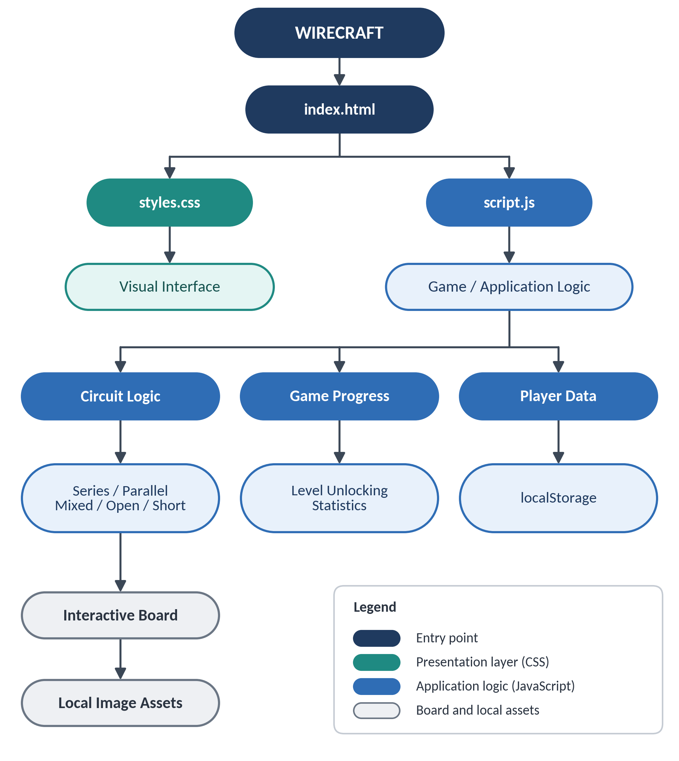

10. APPLICATION DESIGN
10.1 Application Navigation
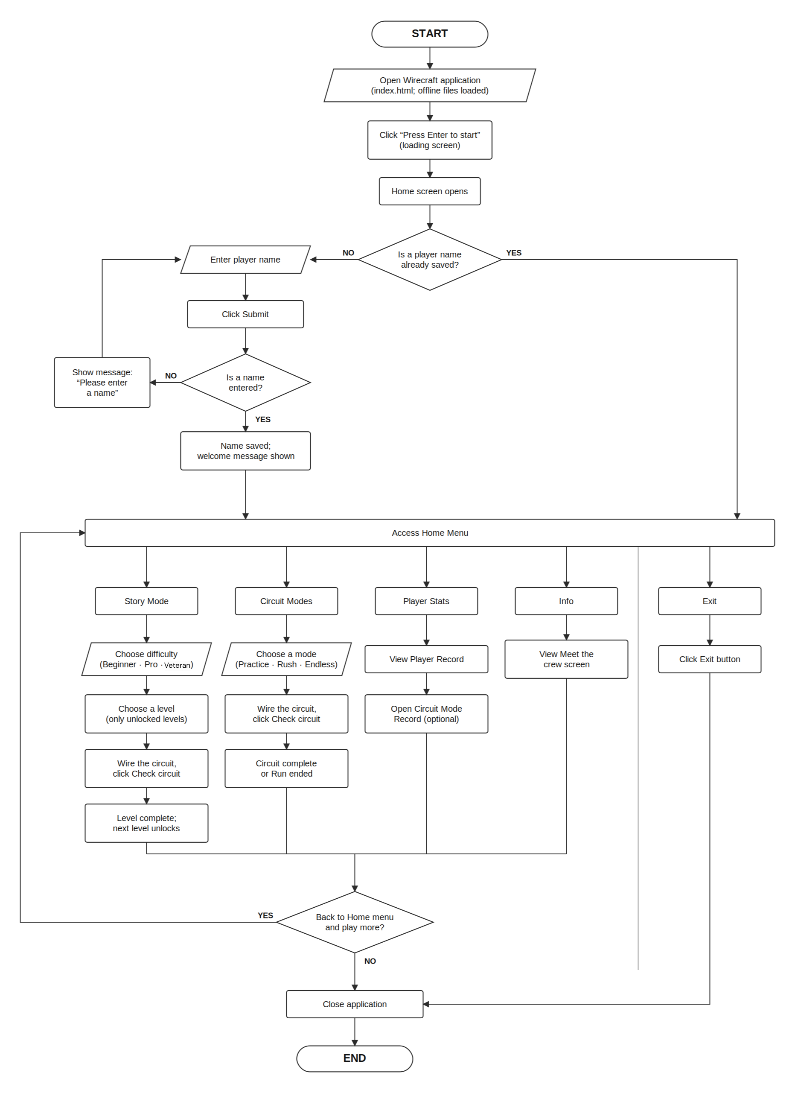
The major navigation flow of WIRECRAFT is:

10.2 Home Screen
The home screen contains:
- WIRECRAFT title
- Player identity
- Player name entry
- Submit button
- Story Mode button
- Casual Mode button
- Exit button
- Player Stats button
- Developer Information button
- Music Toggle button
10.3 Difficulty Screen
Story Mode leads to a difficulty selection screen containing three categories:
- Beginner
- Pro
- Expert
The application initially provides access to Beginner levels. Pro becomes available after the required Beginner progression, and Expert becomes available after the required Pro progression.
10.4 Level Maps
Each difficulty group contains ten levels.
Difficulty | Levels
Beginner | 1–10
Pro | 11–20
Expert | 21–30
The level maps visually represent progression using a route and character graphic.

10.5 Game Board
The game board is the main interactive workspace.
It contains:
- Power source
- Switches
- Bulbs
- Wires
- Circuit panel
- Level information
- Progress indicator
- Objective
- Circuit status
- Control buttons
- Player performance information
10.6 Circuit Model
The application treats the power source as having positive and negative terminals.
Bulbs are polarized:
- Left terminal = positive
- Right terminal = negative
Switch terminals are initially neutral. When connected to a polarized electrical network, the switch terminal can adopt the corresponding polarity.
The game uses these electrical relationships to determine whether the user's circuit is valid.
10.7 Circuit Topology
The application identifies three primary successful topology types:
Series
A series circuit contains one continuous path. Loads are connected in a chain.

Parallel
A parallel circuit contains multiple branches between electrical nodes.
Mixed
A mixed circuit combines series sections with a branching parallel section.
The system can also identify:
- OPEN
- SHORT
These conditions are displayed in the circuit panel.
11. FOLDER AND FILE STRUCTURE
The submitted prototype contains the following major files:
├── index.html
├── styles.css
├── script.js
│
├──easy-map.jpg
├──pro-map.jpg
├──veteran-map.jpg
├──DIFFICULTY.jpg
├── 4350f3ba-1c92-4ba5-b48e-94ffdf669950.jpg
├── killua-chibi-907448.png
├──main_bg.jpg
├──endless.jpg
│
└── .vscode/
└── launch.json

11.1 index.html
The main HTML file defines the application's screens and interface structure.
It contains the:
- Loading screen
- Home screen
- Player statistics screen
- Developer information screen
- Difficulty selection
- Beginner level map
- Pro level map
- Expert level map
- Game interface
11.2 styles.css
The CSS file controls:
- Colors
- Typography
- Layout
- Buttons
- Cards
- Game board
- Circuit components
- Wires
- Animations
- Progress bars
- Responsive behavior
- Hover and active states
The design uses a futuristic/circuit-themed visual style with dark backgrounds, cyan, magenta, green, yellow, and red interface indicators.
11.3 script.js
The JavaScript file contains the main application logic, including:
- Player management
- Local storage
- Level progression
- Level construction
- Circuit components
- Dragging
- Wiring
- Switch behavior
- Circuit topology detection
- Polarity handling
- Short-circuit detection
- Bulb power calculation
- Statistics
- Timers
- Level completion
11.4 Image Assets
The project includes several image assets used primarily for difficulty selection and visual elements of the level maps and application interface.

12. FEATURE DOCUMENTATION
12.1 Player Profile
Purpose
The player profile identifies the current user and allows gameplay statistics to be associated with that player.

How to Use
- Open WIRECRAFT.
- Enter a name in the Enter your name field.
- Click Submit.
- The player's name appears on the home screen.
- The application creates or retrieves the corresponding local player record.
Input
Player name.
Output
The player's name is displayed and associated with saved game statistics.
Special Condition
If a saved player is detected in local storage, the application restores the saved player.

12.2 Change Player Name
Purpose
Allows the active player to change their displayed name.
How to Use
- Open the home screen.
- Click Change name.
- Enter the new player name.
- Submit the new name.
Output
The active player record is associated with the new name.

12.3 Story Mode
Purpose
Provides structured gameplay through progressively challenging circuit levels.
How to Use
- From the home screen, click Story Mode.
- Select a difficulty.
- Select an unlocked level.
- Build the required circuit.
- Complete the level.
- Continue to the next level.

12.4 Circuit Mode
Purpose
Provides direct access to gameplay without first selecting a level from the story difficulty maps.
How to Use
- From the home screen, click Circuit Mode.
- The application opens the game.
- Gameplay begins from Random Level.
- Build the required circuit.

12.5 Difficulty Selection
Purpose
Allows players to choose between the three difficulty groups.
Difficulty Groups
- Easy – Levels 1–10
- Pro – Levels 11–20
- Veteran – Levels 21–30
Unlocking
Pro requires completion of Easy levels 1–10.
Veteran requires completion of Pro levels 11–20.

12.6 Circuit Components
Power Source
The power source provides the positive (+) and negative (−) terminals.
Switch
Switches are controllable components. A normal switch can be toggled between ON and OFF by double-clicking it.
Bulb
Bulbs function as polarized electrical loads. They become visually powered when the circuit provides a valid path through the bulb.
Decoy Components
Higher levels can contain decoy switches or bulbs. These are intentionally unusable puzzle components and generate an incorrect-move response when the player attempts to use them.

12.7 Dragging Components
Purpose
Allows players to organize the circuit workspace.
How to Use
- Place the pointer over a circuit component.
- Press and hold the component.
- Move the pointer.
- Release the component at the desired location.
The wires are redrawn as components are moved.

12.8 Connecting Wires
Purpose
Allows the player to build the circuit.
How to Use
- Select a terminal.
- Drag or move the pointer toward another terminal.
- Release over the destination terminal.
- The application creates the connection.
- The circuit is recalculated.
The application prevents or flags invalid conditions and updates the circuit status.

12.9 Switch Control
Purpose
Allows the player to control whether a switch conducts electricity.
How to Use
- Locate a normal switch.
- Double-click the switch.
- The switch changes between ON and OFF.
- The application recalculates the circuit.
An open switch interrupts the conducting path.

12.10 Circuit Topology Detection
The application analyzes the user's circuit and classifies it.
Possible Results
OPEN
There is no complete conducting path between the positive and negative source terminals.
SHORT
The positive and negative supply paths have been connected through a conducting route that bypasses the required load.
SERIES
The circuit contains one continuous current path.
PARALLEL
The circuit contains multiple branches between the same electrical nodes.
MIXED
The circuit contains both series and parallel sections.

12.11 Short-Circuit Detection
Purpose
Prevents an invalid direct connection between the positive and negative supply paths.
System Response
When a short circuit is detected:
- The status displays a short-circuit warning.
- The wires are visually marked as problematic.
- Bulbs receive a failed/broken visual state.
- A warning notification is displayed.
- The circuit is automatically reset after a short delay.

12.12 Level Completion
Purpose
Determines whether the player has successfully solved a level.
A level is completed when:
- Required bulbs are powered.
- The circuit is valid.
- The required topology is achieved.
- The required components are properly used.
After completion, the application displays:
- Completion message
- Circuit topology
- Number of moves
- Clear time
- Correct moves
- Wrong moves
- Runtime
The player can then proceed to the next level.

12.13 Player Statistics
Purpose
Records the player's gameplay performance.
The statistics include:
- Profile creation date
- Last active date
- Last level
- Number of sessions
- Levels cleared
- Total runtime
- Total moves
- Correct moves
- Wrong moves
- Best clear time

13. TESTING AND VALIDATION
The testing procedure follows the documentation guide's requirement to test both normal and incorrect/incomplete conditions and to document actual results rather than simply stating that everything passed.
13.1 Test Cases
Test ID | Test Action | Expected Result | Actual Result | Status
T-01 | Open index.html without internet | Application loads locally | Application loads successfully from local folder | PASS
T-02 | Enter a player name | Player profile is created | As expected | PASS
T-03 | Reopen application after saving player | Saved player is restored | As expected | PASS
T-04 | Click Story Mode | Difficulty selection appears | As expected | PASS
T-05 | Select Beginner | Beginner level map appears | As expected | PASS
T-06 | Select an unlocked level | Game board opens | As expected | PASS
T-07 | Drag a circuit component | Component moves on board | As expected | PASS
T-08 | Connect valid terminals | Wire is created | As expected | PASS
T-09 | Toggle a switch | Switch changes ON/OFF state | As expected | PASS
T-10 | Create a valid series circuit | Circuit is recognized as SERIES | As expected | PASS
T-11 | Create a valid parallel circuit | Circuit is recognized as PARALLEL | As expected | PASS
T-12 | Create a valid mixed circuit | Circuit is recognized as MIXED | As expected | PASS
T-13 | Leave circuit incomplete | OPEN status is displayed | As expected | PASS
T-14 | Create a short circuit | SHORT warning is displayed and circuit resets | As expected | PASS
T-15 | Complete a level | Completion modal appears | As expected | PASS
T-16 | Continue after completion | Next level becomes available | As expected | PASS
T-17 | Check Player Stats | Player performance is displayed | As expected | PASS
T-18 | Clear/reset the circuit | Wires are removed and circuit resets | As expected | PASS
T-19 | Copy project folder to another location | Application remains functional | As expected | PASS
T-20 | Run application with internet disconnected | Core application remains usable | As expected | PASS
13.2 Testing Evidence
For the final submission, screenshots should be captured for important test cases.
Recommended evidence:
- Figure X – Application opened offline
- Figure X – Player profile
- Figure X – Difficulty selection
- Figure X – Beginner level map
- Figure X – Circuit board
- Figure X – Valid series circuit
- Figure X – Valid parallel circuit
- Figure X – Mixed circuit
- Figure X – Short-circuit warning
- Figure X – Completed level
- Figure X – Player statistics
Screenshots are provided in Appendix A and will be attached as separate image files in the final submission package.

14. USER MANUAL
14.1 Starting WIRECRAFT
- Copy or extract the complete WIRECRAFT project folder.
- Make sure all files remain in their original relative locations.
- Open the project folder.
- Locate index.html.
- Open index.html using a compatible web browser.
- Wait for the WIRECRAFT loading screen.
- The home screen will appear.
No internet connection is required for the main application.

14.2 Creating a Player Profile
- Locate the Enter your name field.
- Type your preferred player name.
- Click Submit.
- Your player name will appear on the home screen.

14.3 Playing Story Mode
- Click Story Mode.
- Choose a difficulty.
- Select an unlocked level.
- Read the objective displayed on the circuit panel.
- Arrange the components if necessary.
- Connect the appropriate terminals.
- Toggle switches when necessary.
- Observe the circuit status.
- Continue making connections until the required circuit is completed.
- After completion, click NEXT LEVEL → to continue.

14.4 Playing Circuit Mode
- Click Circuit Mode.
- The game board opens.
- Read the current objective.
- Build the required circuit.
- Use the circuit controls to check or reset your work.

14.5 Moving Components
- Click and hold a component.
- Drag it to a different location.
- Release the pointer.
- The component remains in the new position.
- Existing wires are visually updated.

14.6 Connecting Components
- Locate the desired terminal.
- Press the terminal.
- Move toward the terminal you want to connect.
- Release the pointer on the destination terminal.
- Check the circuit status.

14.7 Operating Switches
- Locate a normal switch.
- Double-click the switch.
- The switch changes between ON and OFF.
- Observe the circuit status and bulb power.

14.8 Understanding the Circuit Status
The circuit panel provides information about the current circuit.
OPEN
The circuit does not have a complete conducting path.
SERIES
The circuit contains one continuous current path.
PARALLEL
The circuit contains multiple branches.
MIXED
The circuit combines series and parallel sections.
SHORT
The positive and negative supply paths have been connected improperly.

14.9 Resetting a Level
If the circuit becomes difficult to correct:
- Click Reset to rebuild the current level.
- Alternatively, use the Clear control to remove current wiring.
- Rebuild the circuit according to the objective.

14.10 Checking the Circuit
The Check control can be used to update the circuit evaluation.
If the level is not completed, the application provides information such as:
- Number of powered bulbs
- Current topology

14.11 Viewing Player Statistics
- Return to the home screen.
- Click Player stats.
- Review the recorded information.
The statistics page can display the player's:
- Last level
- Sessions
- Levels cleared
- Runtime
- Moves
- Correct moves
- Wrong moves
- Best clear time

15. TROUBLESHOOTING AND MAINTENANCE
15.1 Troubleshooting
Problem | Possible Cause | Solution
Application does not open | index.html is missing or incorrectly opened | Verify that index.html is present.
Design is missing | styles.css is missing or moved | Keep styles.css in the same folder as index.html.
Buttons do not work | script.js is missing or inaccessible | Verify the JavaScript file path.
Images do not appear | Image files were moved | Restore the image files to their original location.
Progress is missing | Browser local storage was cleared | Progress must be restored from a backup if available.
Wires do not display correctly | Files or browser environment changed | Verify project files and use a compatible browser.
Game does not work offline | Required files are missing | Make sure the complete project folder was copied.
A level cannot be opened | Level has not been unlocked | Complete the required preceding levels.
15.2 Maintenance
Future maintainers should:
- Keep all project files in their correct relative paths.
- Avoid renaming files without updating references.
- Back up the entire project folder.
- Test the application after modifying JavaScript.
- Test circuit detection after changes to game logic.
- Remove unused code before final releases.
- Check the browser console for avoidable errors.
- Keep image assets inside the project folder when they are required by the application.

16. PRIVACY, SECURITY, AND ACCESSIBILITY
16.1 Privacy
WIRECRAFT stores player information locally using browser local storage. The player database contains information related to gameplay, such as player name, session information, level progress, moves, and timing information.
Because the information is stored locally, it is associated with the browser/device where the game is played.
Users should avoid entering sensitive personal information as their player name.
16.2 Security
The application does not require users to provide passwords or online account credentials.
Since the application is primarily client-side, its functionality is contained within the submitted web files and local browser storage.
16.3 Accessibility
The application includes several accessibility-oriented features, including:
- Descriptive button labels
- ARIA labels on selected interface elements
- Keyboard-related input handling for the player-name field
- Readable status messages
- Visible button states
- Support for mouse and touch interaction
- Responsive CSS rules for smaller screens
The project should continue to improve accessibility by ensuring sufficient text contrast, readable font sizes, clear focus states, and consistent navigation.

17. LIMITATIONS AND FUTURE IMPROVEMENTS
17.1 Current Limitations
The current version of WIRECRAFT is primarily a local single-device application.
It does not include:
- Online accounts / Online Access
- Cloud synchronization
- Multiplayer functionality
- Online leaderboards
- Real hardware circuit interfaces
- Remote progress backup
- Other lessons of Fundamentals in Electricity and Electronics
- Other necessary items like capacitors and resistors (only wiring diagnostic only)
Player progress can also be affected if browser local storage is cleared.
17.2 Future Improvements
Future versions could include:
- A more detailed tutorial explaining circuit concepts before gameplay.
- Survival mode
- More advanced circuit styles.
- An online leaderboard.
- Cloud-based player accounts.
- Progress synchronization across devices.
- Additional puzzle types.
- More detailed educational explanations after each level.
- Sound effects and optional background music.
- A dedicated settings menu.
- Improved accessibility features.
- More advanced circuit simulation.
- Additional level designs and challenges.
- A teacher/instructor mode for monitoring student progress.

18. CONCLUSION
WIRECRAFT successfully demonstrates the development of an offline web application that combines educational concepts with interactive game mechanics.
The application provides users with an environment where they can manipulate circuit components, connect electrical terminals, operate switches, and construct different circuit topologies. Through its circuit-analysis system, WIRECRAFT can identify open, short, series, parallel, and mixed circuit conditions.
The application also incorporates a progression system consisting of 30 levels divided into Beginner, Pro, and Expert groups. Player information and performance are recorded locally, allowing users to track their progress without requiring an internet connection.
The project demonstrates the practical use of HTML, CSS, and JavaScript in creating an interactive application. It also demonstrates concepts such as DOM manipulation, event handling, SVG graphics, local storage, pointer interaction, circuit graph analysis, and client-side application architecture.
Overall, WIRECRAFT provides an interactive approach to practicing basic circuit concepts while demonstrating how an offline web application can be designed, developed, tested, and documented as a complete software project.

19. REFERENCES
The following sources were used during the development and documentation of WIRECRAFT:
References:
- MDN Web Docs. (n.d.). HTML, CSS, and JavaScript documentation. Mozilla. https://developer.mozilla.org/
- MDN Web Docs. (n.d.). Window: localStorage property. Mozilla. https://developer.mozilla.org/en-US/docs/Web/API/Window/localStorage
- MDN Web Docs. (n.d.). Document Object Model (DOM) and Pointer events. Mozilla. https://developer.mozilla.org/en-US/docs/Web/API/Document_Object_Model
- MDN Web Docs. (n.d.). SVG: Scalable Vector Graphics. Mozilla. https://developer.mozilla.org/en-US/docs/Web/SVG
- Basic electrical circuit concepts (series, parallel, open, and short circuits) drawn from standard electronics education materials and classroom instruction under CPT10.
- Image assets generated with the assistance of generative AI tools (Gemini) and public-domain/character-style graphics used for visual theme only.
- No external JavaScript libraries or frameworks were used; the application is built with pure HTML5, CSS3, and vanilla JavaScript.
- AI tools (including Grok / CHATgpt and Gemini) were used to assist in documentation drafting, code structuring ideas, and generation of some visual assets. All final code and documentation content were reviewed and finalized by the project team.
All external materials and AI assistance have been credited above in accordance with the CPT10 documentation requirements.

20. APPENDICES
APPENDIX A – APPLICATION SCREENSHOTS
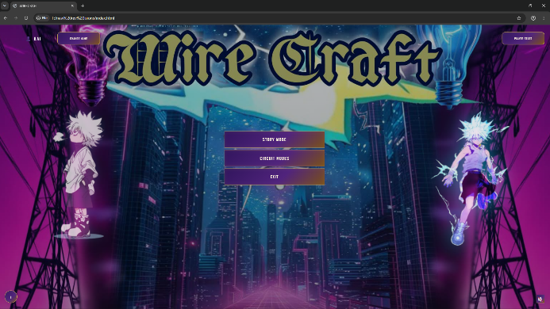
WIRECRAFT Home Screen

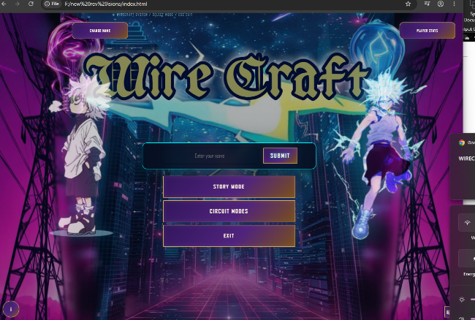
Player Name Entry

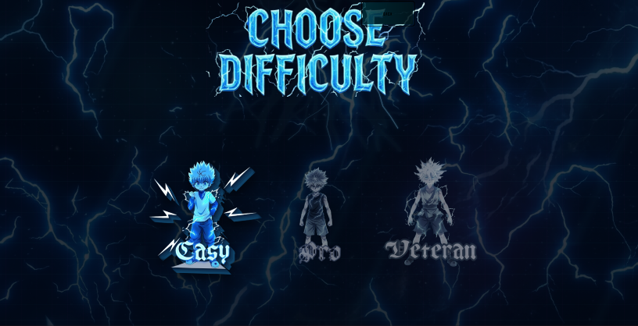
Difficulty Selection

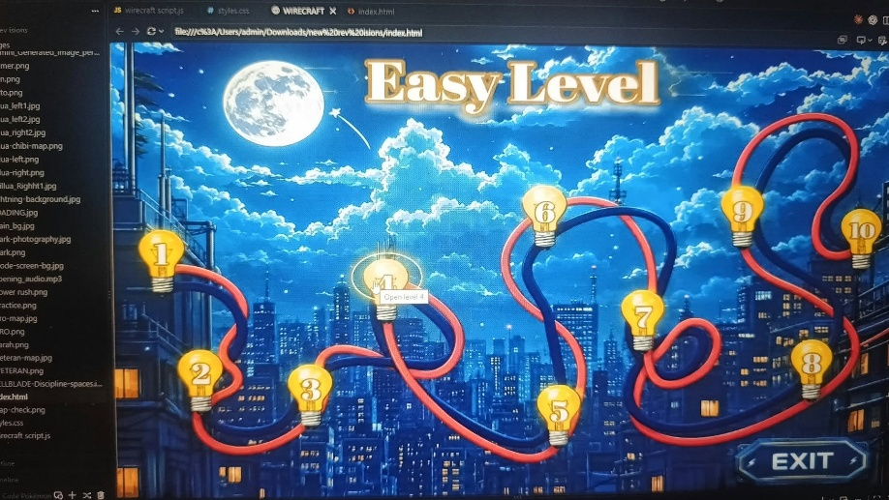
Easy Level Map

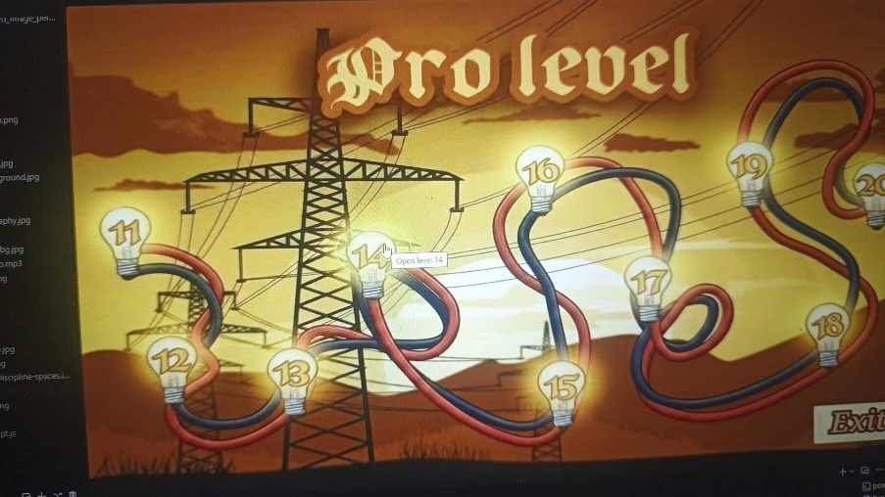
Figure A6. Pro Level Map

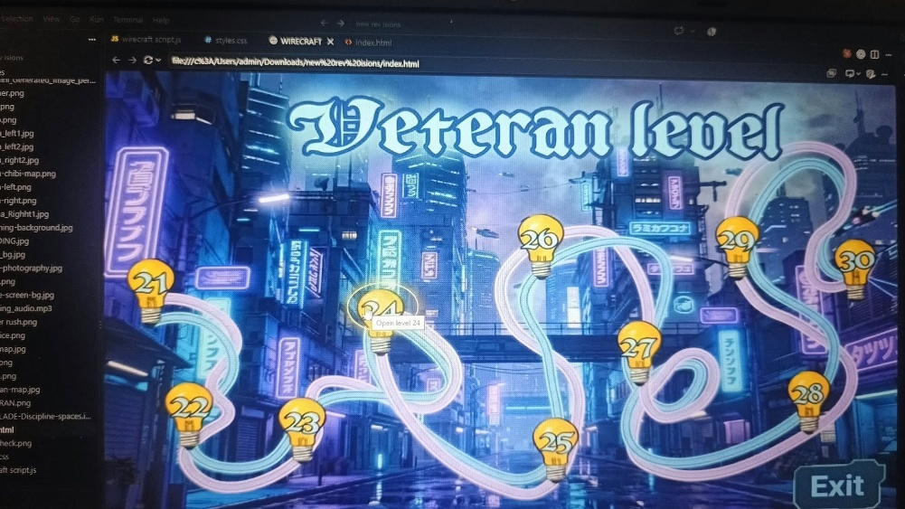
Figure A7. Expert Level Map

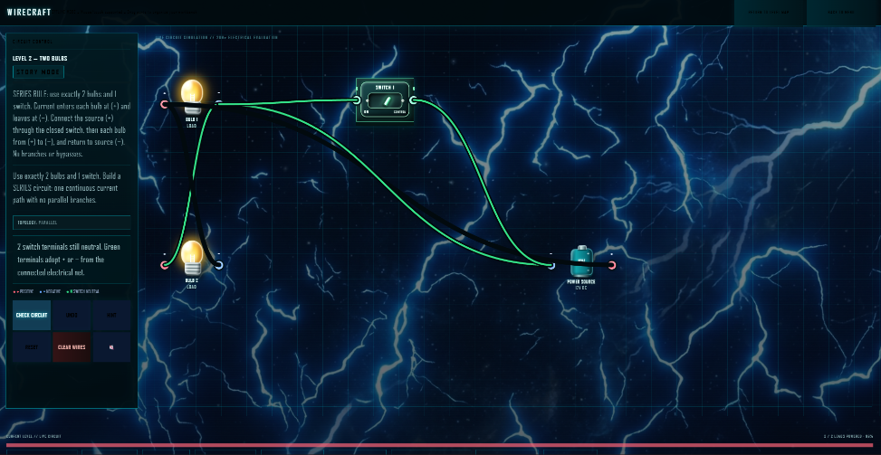
Short-Circuit Warning (red progress bar)

Figure A14. Level Completion
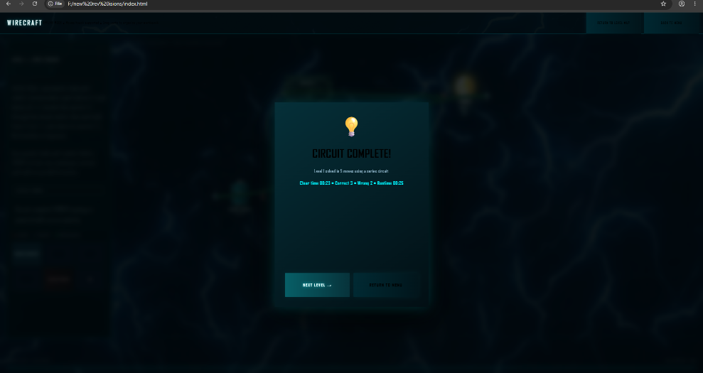
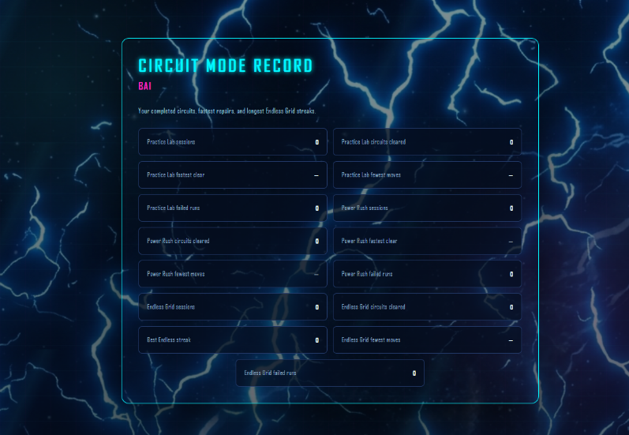
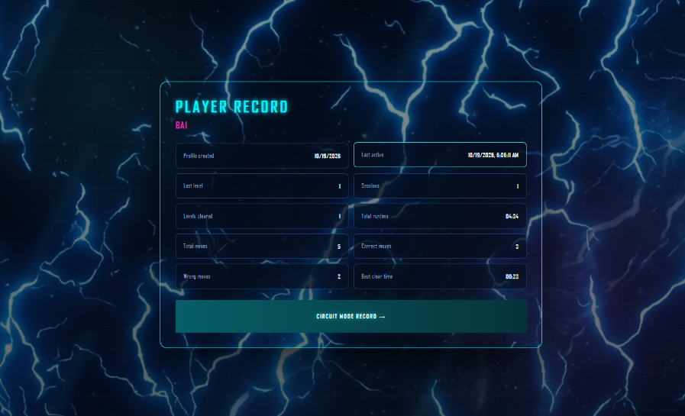
Figure A15. Player Statistics

APPENDIX B – LEVEL DESIGN
The application contains 30 levels with the following objectives:
Level | Name | Switches | Bulbs | Target
1 | First Circuit | 1 | 1 | Series
2 | Two Bulbs | 1 | 2 | Series
3 | Switch It | 1 | 2 | Series
4 | Series | 1 | 2 | Series
5 | Choice | 2 | 2 | Parallel
6 | Crossover | 2 | 2 | Parallel
7 | Three Loads | 2 | 3 | Series
8 | Detour | 2 | 2 | Series
9 | Reverse | 2 | 2 | Series
10 | Double Switch | 2 | 2 | Series
11 | Parallel | 2 | 3 | Parallel
12 | Red Herring | 2 | 2 | Parallel
13 | Split Path | 2 | 3 | Parallel
14 | Three Switches | 3 | 2 | Series
15 | Mixed Grid | 3 | 3 | Mixed
16 | Long Route | 3 | 3 | Series
17 | Triple Load | 3 | 3 | Parallel
18 | Decoy Terminals | 3 | 3 | Mixed
19 | Series + Parallel | 3 | 4 | Mixed
20 | Locked Route | 4 | 3 | Series
21 | Four Loads | 4 | 4 | Parallel
22 | Maze | 4 | 4 | Mixed
23 | Switch Maze | 4 | 4 | Mixed
24 | Polarity | 4 | 4 | Mixed
25 | Dense Board | 5 | 4 | Parallel
26 | Multi Path | 5 | 4 | Mixed
27 | Red Herring II | 5 | 5 | Mixed
28 | Complex Loop | 5 | 5 | Mixed
29 | Master Circuit | 6 | 5 | Mixed
30 | Wirecraft Master | 7 | 6 | Mixed

APPENDIX C – PLAYER STATISTICS
The application records the following player information:
Statistic | Description
Profile Created | Date the player profile was created
Last Active | Most recent recorded activity
Last Level | Most recently reached level
Sessions | Number of recorded gameplay sessions
Levels Cleared | Number of completed levels
Total Runtime | Total recorded gameplay runtime
Total Moves | Total number of connection attempts/moves
Correct Moves | Number of accepted moves
Wrong Moves | Number of incorrect moves
Best Clear Time | Fastest recorded level completion time

APPENDIX D – DOCUMENTATION CHECKLIST
Before submitting the project, confirm the following:
- WIRECRAFT opens from the submitted folder.
- The application works without internet access.
- index.html is included.
- styles.css is included.
- script.js is included.
- All required image assets are included.
- Relative file paths work.
- Player profile functionality works.
- Story Mode works.
- Casual Mode works.
- Beginner levels work.
- Pro unlocking works.
- Expert unlocking works.
- Circuit components can be moved.
- Wires can be connected.
- Switches can be toggled.
- Series detection works.
- Parallel detection works.
- Mixed detection works.
- Open-circuit detection works.
- Short-circuit detection works.
- Level completion works.
- Player statistics are recorded.
- Reset controls work.
- Screenshots are clear and numbered.
- Testing results are recorded honestly.
- References and credits are complete.
- The complete folder has been copied/extracted and tested in another location.

APPENDIX E – PROJECT SUBMISSION STRUCTURE
TEAM KAMOTE_WIRECRAFT/
│
├── app/
│ └── prototype/
│ ├── index.html
│ ├── styles.css
│ ├── script.js
│ ├── image assets...
│ └── .vscode/
│
├── documentation/
│ ├── TEAM KAMOTE_WIRECRAFT_Documentation.docx
│ ├── TEAM KAMOTE_WIRECRAFT_User_Manual.pdf
│ │
│ ├── screenshots/
│ │ ├── Figure_01.png
│ │ ├── Figure_02.png
│ │ └── ...
│ │
│ └── test-records/
│ └── Testing_Record.xlsx
│ |
└── README.txt
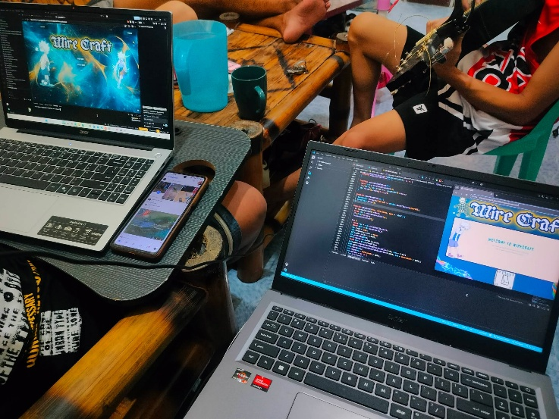
Pictures during the creation of web application
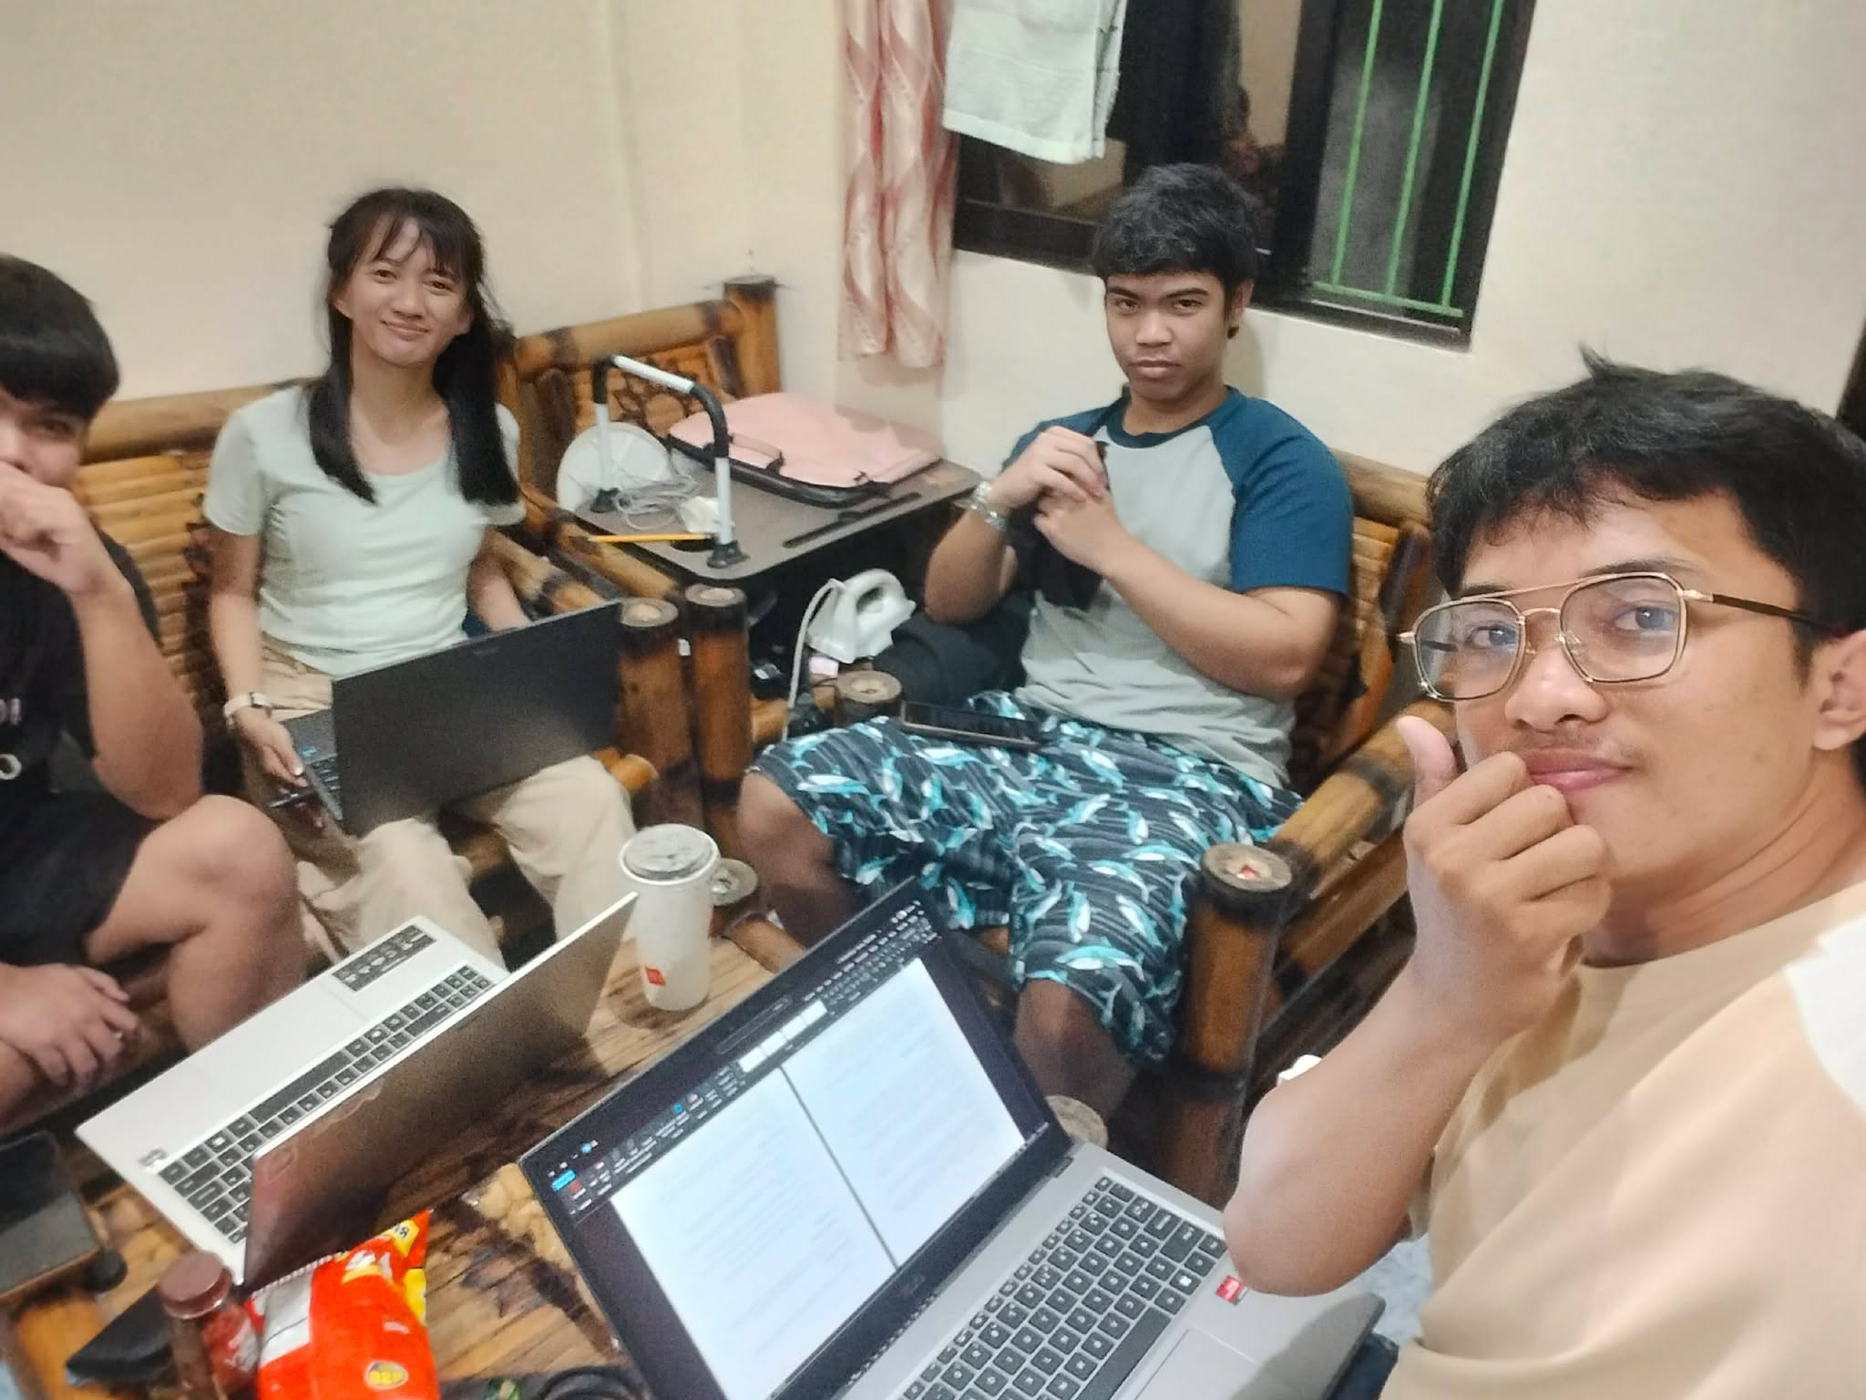
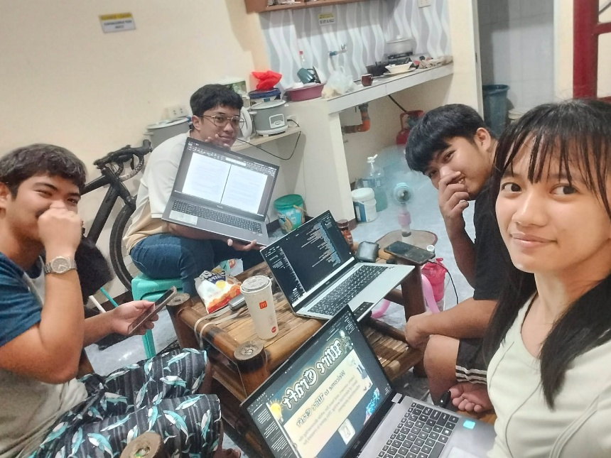
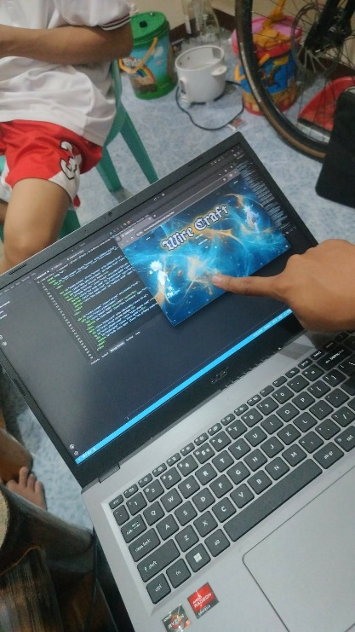

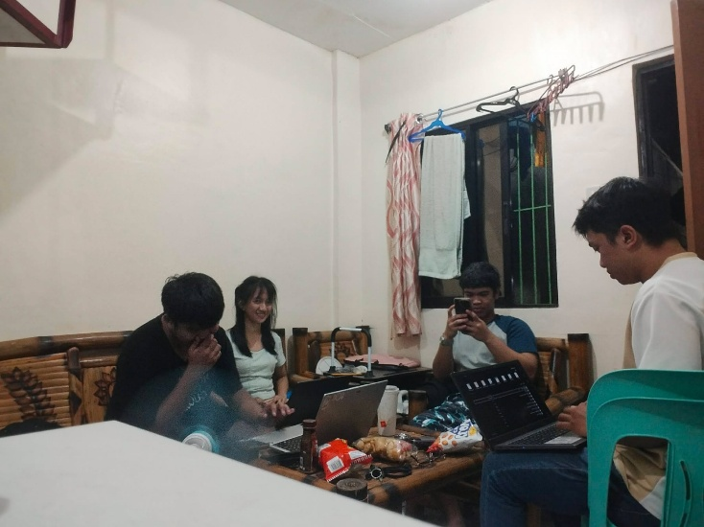

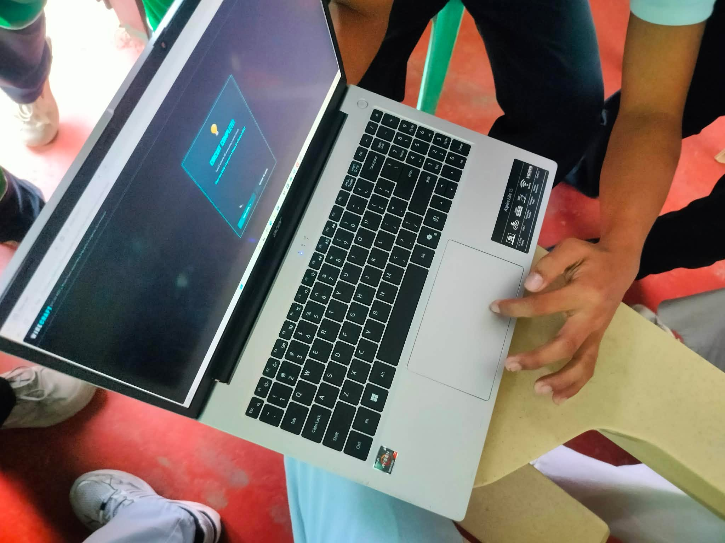

Pictures of actual testing of the Web App


